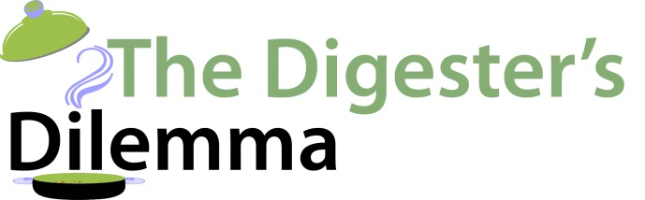

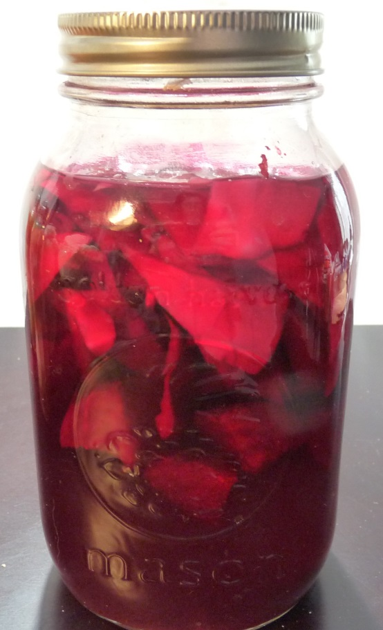

The Simply Fermentation Workshop Recipes

With Lorene Sauro, RHN
www.thedigestersdilemma.com

