Understanding Fermented Foods –
Your Quick Guide to Choosing the Ones That Are Right for You


Insert Name Here
Hello and thank you for downloading “Understanding Fermented Foods - Your Quick Guide to Choosing the Ones That Are Right for You.”
You have just taken an important first step, and my goal is to make it as simple as possible for you to get started on the journey to better gut health.
Consuming fermented foods is an easy step. You can purchase many of them at your local health food store or grocery store, and you can learn to make your own. But adding them to your diet is the important part. Use this guide to learn some of the benefits of each type of fermented food and then make your choice. There are many delicious ways to add fermented foods to your diet, and I would be happy to help you with suggestions.
If you have any questions, please feel free to contact me at (PHONE NUMBER) or (EMAIL).
Enjoy!

Signature
 (Place HEADSHOT)
Contact info (optional)
(Place LOGO)

Medical Disclaimer
All information contained in this document is for informational purposes only. It is not intended to diagnose, treat, cure, or prevent health problems. For all serious health issues, please contact a medical or nutrition practitioner. The information provided in this program is based on the best knowledge of the author at the time of writing, and we do not assume liability for the information within this program, be it direct or indirect, consequential, special, exemplary, or other damages. In all circumstances, it is always wise to consult your physician before changing your diet, taking supplements, or starting any exercise or health program.

Understanding Fermented Foods
Fermented foods are unique. For many years, fermenting was considered just a way to preserve food. Now we know that fermenting allows beneficial bacteria and sometimes yeast strains to build up in the food, turning it into a powerhouse of nutrients that helps the gut and the rest of the body.
Research does exist for fermented foods, plus there is a lot of historical information as to how they have been used in the past.
Most fermented foods are made with an anaerobic process, meaning the good bacteria build up lactic acid bacteria and other acids without oxygen. This means that there are no molds or bad bacteria present.
Sauerkraut, kimchi, beet kvass, and cultured vegetables are generally made with a salt brine, although homemade versions can be made from whey (strained from yogurt) or a vegetable starter.
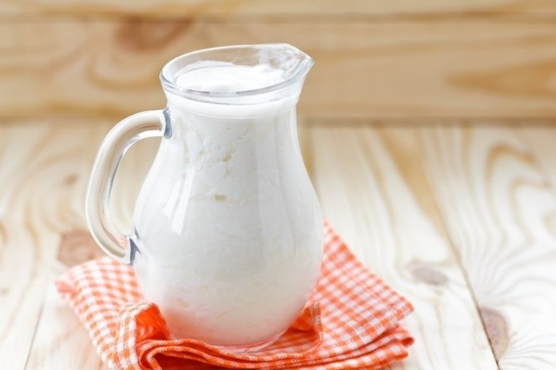
Milk kefir, water kefir, and kombucha also use an anaerobic process but must be made with a “SCOBY” (symbiotic culture of bacteria and yeast). This means that both beneficial strains of bacteria and yeast are present.
Sourdough bread is made with a “starter” using an aerobic process. Oxygen is needed for the development of the wild yeasts. Wine and beer are also made with an aerobic process.
Most fermented foods contain various types of lactic acid bacteria which means they produce lactic acid. Wine and vinegars like apple cider vinegar or real balsamic vinegar have strains that produce acetic acid. All are beneficial.
As for the benefits, three different studies have compared the microbiomes of rural Africans, Japanese, and South Americans consuming a traditional diet with plenty of fermented foods. Researchers found that those consuming the traditional diet had higher levels of beneficial lactobacillus and bifidus strains and lower levels of pathogenic strains such as clostridium than people living in western urban centres.
Individually, each fermented food has been studied and found to be helpful in a number of ways. Some of the benefits for each fermented food are highlighted below. Learning more about each should make it easier for you to choose the right ones. However, the best way to choose is to try them.

How Do You Use Fermented Foods?
- Fermented foods can be consumed on their own as a snack or served with a meal to aid digestion of the meal.
- Kefir, yogurt, kombucha, and pureed sauerkraut or sauerkraut juice work well in salad dressings, replacing some of the vinegar because they are all acids too, just not as strong.
- Sauerkraut, cultured vegetables, and kimchi can be added to soups. Add after the soup has been ladled into the bowl.
- Yogurt, kefir, sauerkraut, kombucha, and beet kvass can be added to smoothies.
- A delicious beverage can be made by adding fresh juice to water kefir or kombucha.
Are the Benefits of Fermented Foods Lost When Cooked?
No. You will lose the enzymes, beneficial bacteria, and yeast strains. However, the microorganisms produce beneficial metabolites during the fermentation process, and these remain available to provide health benefits for the body. Also, the food that is fermented is somewhat predigested, and the nutrients in the food have been made more bioavailable. These benefits remain in the food even if it has been cooked.
How Much Should You Consume?
A study looked at people who consumed at least three different types of fermented food and had at least five servings per week. The fermented foods were removed for two weeks, and immune response was lowered. Yogurt was added back first and while immune response improved, it did not return to previous levels until all the fermented foods were added back in. Quantity and diversity matter.
Easiest plan: Have a serving of one fermented food every day, and choose three different types to rotate throughout the week.
What Is the Best Serving Size?
Try to consume 1/4– 1/2 cup for sauerkraut, kimchi, yogurt, and kefir. For beverages such as water kefir and kombucha, 8 oz (224 ml) is a good amount. For beet kvass, 2–4 oz (56–112 ml).

The Easiest Fermented Foods to Buy:
Many good-quality fermented foods are easy to find in the health food stores and many grocery stores. Real fermented foods, with the exception of wine, will be found in the refrigerator case. Those found on the store shelf have been pasteurized and will no longer have the active bacteria. These are the ones you will most likely find:

Sauerkraut
Sauerkraut is made by “sweating” the juice out of the cabbage with salt to create a brine. This is a simple process of rubbing cabbage with the salt. All the benefits of cabbage are present but in a more bioavailable form. Other vegetables or herbs can be used to add to the flavour and to increase the nutrient diversity.
Sauerkraut has many benefits. It is antimicrobial and antifungal, and the juice can be used to preserve other foods. Phytonutrients found in cabbage, known as isothiocyanates, may have anticancer benefits and may be helpful with ulcers.
Sauerkraut aids digestion and helps digestion of other foods in the meal. It also contains prebiotics which help feed our own good bacteria.
Kimchi
The benefits of kimchi come from several key foods as it is a combination of cabbage, carrots, onions, garlic, ginger, daikon radish, and hot red pepper powder (capsaicin). It helps carbohydrate metabolism, and the capsaicin in the red pepper powder may boost the body’s metabolism. It also contains the same isothiocyanates as sauerkraut which may help stomach cancer.
Kimchi can help boost the immune system. It aids digestion of all the food in the meal, has antimicrobial properties, aids intestinal health, and helps prevent constipation. A study found that bacillus pumilus, a strain found in kimchi, helped detox carcinogens and estrogen-mimicker Bisphenol A (found in plastic).
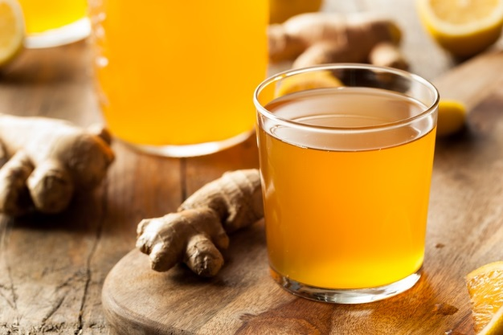
Kombucha
Kombucha is unique as it is made with a SCOBY (symbiotic colony of bacteria and yeast), tea (with caffeine), and sugar. It aids digestion, helps stabilize blood sugar, and has antimicrobial properties. It may also help with cholesterol, and it offers beneficial antioxidant protection.
Research of kombucha focusses on the polyphenols found in black tea. They are more bioavailable in kombucha which can explain a lot of the health benefits.
Milk Kefir
Milk kefir originated from the Caucasus mountains in Russia. Despite attempts to duplicate them, only kefir grains can make traditional kefir. They are a symbiotic combination of 32 strains of good bacteria (both lactic acid and acetic acid strains) and yeast strains.
Kefir has anti-inflammatory properties and may help reduce histamine, the chemical released during an allergic reaction. It may aid those who are lactose intolerant. Kefir is well-researched and has been shown to have anticancer properties, help reduce inflammation, and stabilize blood sugar. It also helps inhibit candida albicans. And like all fermented foods, it aids digestion.
Kefir works best when made with cow and goat milk as the lactose and GOS help feed the grains. It can be made with coconut milk, but some type of carbohydrate such as date puree must be added to feed the grains.
Yogurt
Yogurt is one of the oldest fermented foods and is made from at least two to four strains of good bacteria. It is common to more cultures than any other types of fermented food except perhaps wine or cheese. Different cultures use different strains for making yogurt. Cow, sheep, yak, goat milk – all have been traditionally used for yogurt. In North America, yogurt is typically made with the strains Lactobacillus bulgaricus and Streptococcus thermophilus.
Commercial yogurt may be fermented in as little as an hour with thickening agents such as gelatin or modified cornstarch being added. In order to break down enough lactose and have a significant amount of good bacteria, yogurt must be fermented for at least four hours or longer. Specialty yogurts like Mediterranean and Greek are also popular – both involve the process of straining whey to make it thicker. Zero percent Greek yogurt is made with non-fat milk. Whole milk yogurts have more nutrients than Greek.
Real yogurt should only contain two ingredients: milk and bacterial culture.
Studies on yogurt are inconsistent – mainly because they do not specify what type of yogurt was studied. What is known is that it aids digestion and helps support immune function. It may also be helpful for ulcers.

Sourdough Bread
Sourdough is made from a starter of flour and water that has been fermented by wild yeasts and lactic acid bacteria. A good starter or “sponge” can last for decades and be passed down from one generation to another. The fermentation process changes how the grain is used by the body.
It makes the nutrients in the grains such as zinc, iron, magnesium, B vitamins, and phytonutrients more available to be absorbed into the body. The yeast actually produces the B vitamins (even in white bread). It also helps break down the gluten and starches making the bread more digestible. Many people who have digestive issues with wheat have no issues with sourdough bread made with wheat.
Research has shown that sourdough does not spike blood sugar and insulin release, even when made with white flour. One study found that consuming sourdough in one meal positively affected blood sugar for that meal and the next. (Breakfast may be the best time to consume it.)
Look for sourdough bread at local bakeries. Some grocery and health food stores are now selling sourdough bread. It may also be available online and sold frozen.
Wine and Beer
Is there a place for wine and beer in a healthy diet? Yes. Both are traditionally fermented foods. Both are low in alcohol (in comparison to hard liquor).
Beer

To be beneficial for gut health, beer must be unpasteurized. This ensures that the good bacteria and yeast are present. Many commercial beers are pasteurized so be careful when choosing. Beer contains B vitamins and silicon which blocks the uptake of aluminum and may help prevent Alzheimer’s. Beer also contains hops which are anti-inflammatory and may help with sleep.
Wine
The health benefits of red wine are well known: anti-inflammatory, antioxidant, anti-aging, anticancer, and may help prevent heart disease. This is due to the phytonutrients known as the polyphenols which also happen to be prebiotic and feed good bacteria in the gut.
Wine is traditionally served with a meal to aid digestion. Most studies are on red wine, but white wine has high phenolic values as well. As long as they are consumed in moderation, red and white wine can be part of a healthy diet.
Vinegars
Apple cider vinegar with mother (meaning it has the remnants of the apple in it) is a true fermented food. The same is true of an aged balsamic vinegar. There are other vinegars that are fermented, but these two are the easiest to find, have many health benefits, and are rich in nutrients. Even though we only consume a small amount, they are still worthwhile to add to our diet.
Don’t Forget About Cheese
All real cheese is made from a fermented process, but it’s the hard, aged cheeses like natural cheddar and parmesan that have the most benefits. The older the cheese, the more the lactose is broken down and the more enzymes and beneficial bacteria are present. Look for cheeses made from raw milk, preferably organic, as these are the very best. Milk has many properties that are good for the gut and consuming a fermented version makes it more digestible.

Fermented Foods That You Would Have to Make:
Jun Kombucha
The Jun SCOBY evolved from the regular Kombucha SCOBY many years ago, but it’s made with green tea and honey instead of black tea and sugar. It has similar benefits to kombucha with regard to aiding digestion and stabilizing blood sugar, and it’s antimicrobial. Jun kombucha, unlike regular kombucha, contains mainly lactobacillus strains. Some compare its taste to champagne.
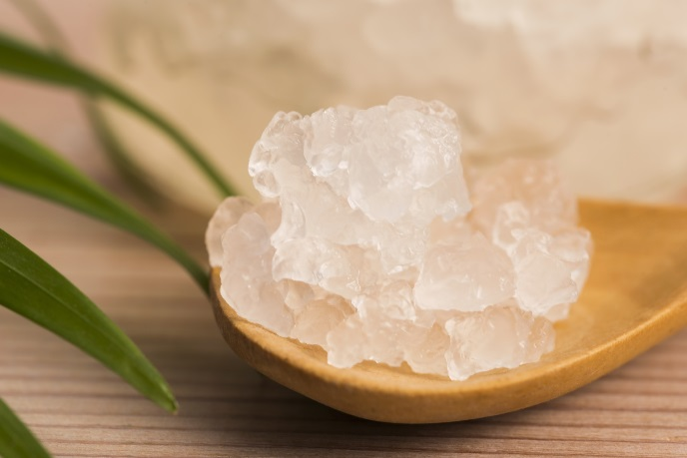
Water Kefir
Water kefir is made with water kefir grains, which are a symbiotic combination of good bacteria and yeast. The exact origin of water kefir grains is unknown – some say Mexico and others says Japan, but no one knows for sure. It’s considered to be immune supportive and contains antioxidants that increase the more it ferments.
Like other fermented foods, water kefir aids digestion and stabilizes blood sugar. It also makes B vitamins.
Beet Kvass
Beet kvass, as well as milk kefir and other fermented foods, is well known in the Caucasus Mountains. It was used as a means to clean water, allowing the good bacteria to take care of the bad. Often raisins or other fruits and vegetables are added to create a unique beverage. Beets contain nitrates but fermentation converts nitrates to nitric oxide. Nitric oxide increases blood flow to the brain to help improve cognitive function, and it may help prevent dementia.
All the health benefits of beets apply to beet kvass, and the nutrients are more bioavailable – plus kvass contains good bacteria. This means that beet kvass has phytonutrients that act as antioxidants and anti-inflammatories.
Cultured Vegetables
The number one health benefit of culturing vegetables is making the vegetables more digestible and the nutrients more bioavailable. Each vegetable has it owns health benefits based on the vitamin, mineral, and phytonutrient content. There is very little research on the culturing of vegetables as each food that could be cultured would have to be studied, and there are no limits to what can be fermented.


Your Name & Title (optional)
Short BIO and reason for your program

(Place Your Photo here)
I created the Your program name to help provide my clients with the knowledge that allows them to understand how to support their bodies more effectively. Gut health is an ever-evolving topic. The research is coming so fast and furiously that it may seem impossible to keep up.
And let’s face it – gut research is changing everything. Many “experts” are jumping the gun and presenting assumptions as facts and making the situation more complicated for all of us. And, unfortunately, their focus seems to all be on food – making good-quality whole foods the bad guy. My goal is to help you find the foods that work best for you.
Different cookie-cutter diets are being recommended, but the long-term results show that this doesn’t work. We are complicated and taking a more foundational approach allows the body to correct itself. This requires patience and customization.
The Your program name provides a framework to make this possible, including:
Describe emotional benefits of your program

Click Here to Learn More

Describe the elements and materials in your program

Add Link to Your Program

Add Logo

