The Quick-Start Guide
to Adding Fermented Foods to Your Diet

Hello. Thank you for downloading “The Quick-Start Guide to Adding Fermented Foods to Your Diet.”
Insert Name Here
If you’re considering adding fermented foods to your diet, you have just taken an important first step to helping your gut health.
Issues with the gut have been linked to all health conditions. One of the simplest ways to support the gut is to feed it foods that help it function. Fermented foods contain good bacteria which help our own good bacteria do their job. They also contain prebiotics which help feed our own residential good bacteria. This is a win-win. Having a healthy level of gut bacteria will allow us to feel the benefits and enjoy vibrant health.
If you have any questions, please feel free to contact me at (PHONE NUMBER) or (EMAIL).
Enjoy!

Signature
 (Place HEADSHOT)
Contact info (optional)
(Place LOGO)

Medical Disclaimer
All information contained in this document is for informational purposes only. It is not intended to diagnose, treat, cure, or prevent health problems. For all serious health issues, please contact a medical or nutrition practitioner. The information provided in this program is based on the best knowledge of the author at the time of writing, and we do not assume liability for the information within this program, be it direct or indirect, consequential, special, exemplary, or other damages. In all circumstances, it is always wise to consult your physician before changing your diet, taking supplements, or starting any exercise or health program.

How
- The first thing to do is to try different types of fermented foods.
- In order to figure out how and what to incorporate into your diet, you need to know what you like.
- The key, long term, is consistency.
- You can start by making the recipes here one at a time.
- Pick one type and start.
Or
- There are good brands of sauerkraut, kombucha, kimchi, and cultured vegetables available at the health food store and some grocery stores. They will be in the refrigerator section – not on the shelf.
- Try them to see what you like.

- Remember that the fermented food you make will taste better as you learn how to make it the way you like.

How To Consume Fermented Foods
There are three ways to consume fermented foods:
- Eat them, as is.
- Work them into a recipe, as is.
- Cook with them in a recipe.

Eating Them, As Is
- All fermented foods contain beneficial bacteria that have various benefits.
- To get all of the benefits, the fermented food must be consumed, as is.
- It can be as simple as just having a quarter cup of sauerkraut or kimchi as a snack or as a side dish with a meal.
- If the fermented food is a drink or liquid, just take it as a shot.

The Tastiest Way
- The best way to use fermented foods is to find recipes that you can incorporate them into or that already call for them as part of the recipe.
- There are several options with each type of fermented food in this course.
- The key is to work with the unique flavours of each food and match it with flavours that complement.

Adding Fermented Foods
- An existing recipe you have such as a soup can be topped with the fermented food – this allows the fermented food to be warm without killing the bacteria.
- It takes 20 minutes at 140–160 degrees F (60–71 degrees C) to kill bacteria during pasteurization.
- This allows flexibility when adding the foods to existing recipes – it’s about when and how.

Complementing
- Some fermented foods are salty – sauerkraut, kimchi, beet kvass, and cultured vegetables that are fermented in brine.
- These should be matched with foods that are bland – they would be great in a vegetable smoothie or even a fruit one; or add to something that generally requires added salt, and the fermented food can be used instead.


Complementing
- Some fermented foods like kombucha, milk kefir, and kefir water are sour…
- Not as sour as vinegar but often can be used to replace some of the vinegar in a recipe
- Sour fermented foods can be matched with bland or sweet food or with another acid like an acid fruit.
- Sometimes a combination of different types of flavours is best.

Cooking with Fermented Foods
- The good bacteria and enzymes will be lost but...
- The vitamins, minerals, and phytonutrients that were made more bioavailable by fermenting will still be bioavailable.
- The fermented foods are somewhat predigested, and this benefit remains as well.
- Many traditional recipes cook the fermented foods.


Fermenting and Baking
- Sourdough bread is an example of fermenting the grains and then baking them – killing the bacteria and yeast but maintaining the predigestion and the bioavailability of the nutrients.
- Fermenting the grains or legumes is a technique that can be used in other types of recipes, but these are always cooked or baked after fermenting.

Once You Know What You Like
- Pick three types of fermented foods that you like, and find ways to consume these throughout the week.
- Always try a small amount first and see how you react, and then once you are comfortable with how they make you feel, increase the amount.
- Try one a day – that would be great. Two would be even better.
- Consume amounts as small as a couple of tablespoons up to a 1/4–1/2 cup. Do what feels right for you.

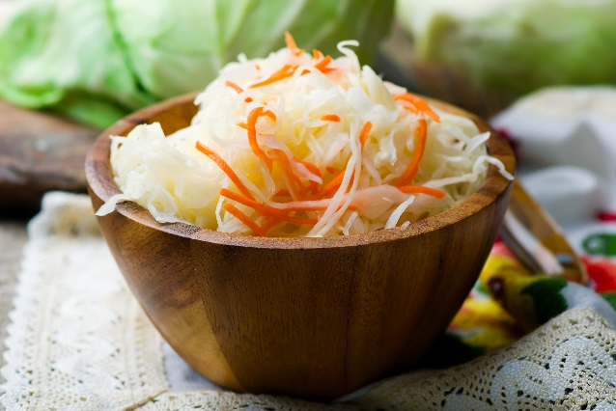
To Help You Decide
- Sauerkraut and beet kvass are the best for healing and aiding overall digestive function.
- Milk kefir or coconut milk kefir are best for gut health and colon function with water kefir being the next best.
- Kimchi aids overall digestion.
- Cultured vegetables and all fermented foods aid the digestion of other foods in the meal.

And Finally…
- If making fermented foods all the time is difficult, then buy them when you can’t make them.
- The important thing is to eat fermented foods on a regular basis.
- It’s also important to enjoy the foods so finding the right recipes is the key to your enjoyment.
- It’s now time to start the adventure!


Your Name & Title (optional)
Short BIO and reason for your program.

(Place Your Photo here)
I created the Name of your program to help provide my clients with the knowledge that allows them to understand how to support their bodies more effectively. Gut health is an ever-evolving topic. The research is coming so fast and furiously that it may seem impossible to keep up.
And let’s face it – gut research is changing everything. Many “experts” are jumping the gun and presenting assumptions as facts and making the situation more complicated for all of us. And, unfortunately, their focus seems to all be on food – making good-quality whole foods the bad guy. My goal is to help you find the foods that work best for you.
Different cookie-cutter diets are being recommended, but the long-term results show that this doesn’t work. We are complicated and taking a more foundational approach allows the body to correct itself. It requires patience and customization. Fermented foods are a first positive step.
The Your program name will teach you more ways to help your gut and will provide a framework to make this possible, including:
Describe emotional benefits of your program

Click Here to Learn More

Describe the elements and materials in your program

Add Link to Your Program

Add Logo

