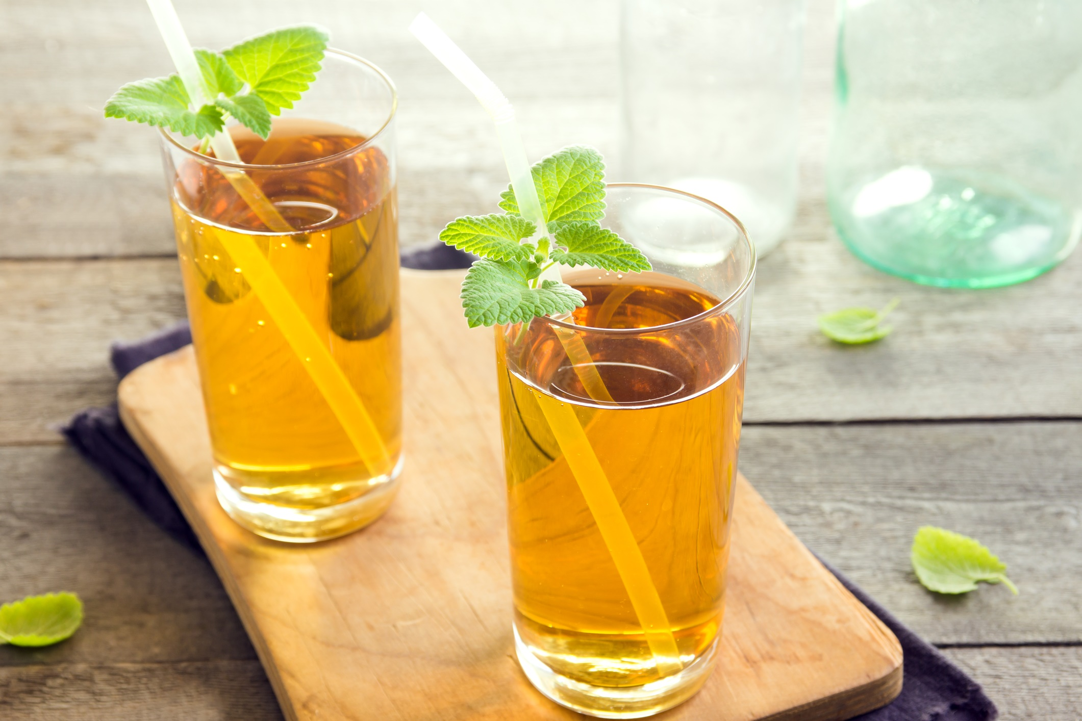

Insert Name Here
The Art of
Making Kombucha
Insert Name Here
Hello.
I am so pleased to offer you this information about making kombucha. Fermentation is a traditional preservation technique for creating foods with even more health properties because they have been fermented.
Beneficial bacteria are essential for a healthy gut. And a healthy gut is necessary for a healthy body. Fermented foods such as kombucha deliver beneficial bacteria to help the gut and help you. It’s a fascinating technique, and I’m sure you will enjoy learning to make your own kombucha.

Signature
 (Place HEADSHOT)
Contact info (optional)
(Place LOGO)

Medical Disclaimer
All information contained in this document is for informational purposes only. It is not intended to diagnose, treat, cure, or prevent health problems. For all serious health issues, please contact a medical or nutrition practitioner. The information provided in this program is based on the best knowledge of the author at the time of writing, and we do not assume liability for the information within this program, be it direct or indirect, consequential, special, exemplary, or other damages. In all circumstances, it is always wise to consult your physician before changing your diet, taking supplements, or starting any exercise or health program.
Kombucha has a long and noble history. It’s been used for many years in several cultures and there are different versions. It’s unique as it is made with a SCOBY (symbiotic colony of bacteria and yeast), tea (with caffeine), and sugar.
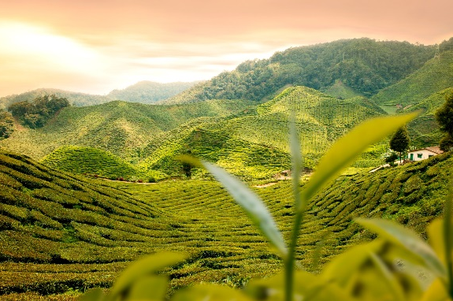
Kombucha aids digestion, helps stabilize blood sugar, and has antimicrobial properties. It may also help with cholesterol and offer beneficial antioxidant protection. Traditionally it has been used for colds and flus.
Research of kombucha focusses on the tea polyphenols found in black tea. These are more bioavailable in kombucha which can explain a lot of the health benefits.
Jun Kombucha evolved from the regular kombucha SCOBY, but it’s made with green tea and honey. It has a lighter taste. Some compare the taste to champagne.

Tips for Making Kombucha

What is a SCOBY?
As mentioned above, it’s a symbiotic culture of bacteria and yeast (SCOBY), containing Acetobacter (a genus of acetic acid bacteria) as well as other bacteria and one or more yeasts, which forms a zoogleal mat (a complex population of organisms that form a slime growth) – Wikipedia. Sounds tasty.

Kombucha
- The fermentation process occurs with oxygen as yeast need oxygen, and the good bacteria strains are good with it as well.
- During the fermentation process the tea ferments, and the organisms produce acetic acid, gluconic acid, and succinic acid and some lactic acid and alcohol (ethanol).
- The pH should drop to around 3.5 .

Equipment Needed
- Kettle or pot for boiling water
- Tightly woven cloth (tea cloth material) with an elastic band
- Measuring cup for measuring sugar
- 2-cup measuring cup (or 4-cup) for straining out kombucha
- 1-gallon or 4-litre glass container
- 3–4 1-litre or 1-quart Mason jars with lids for finished kombucha
- Nylon mesh strainer

Making Kombucha
- Organic tea, if possible, should be used, and it should be black, green (must be used with black tea), oolong, or jasmine tea.
- Flavoured teas like Earl Grey must not be used as the flavours or oil can possibly harm the SCOBY.
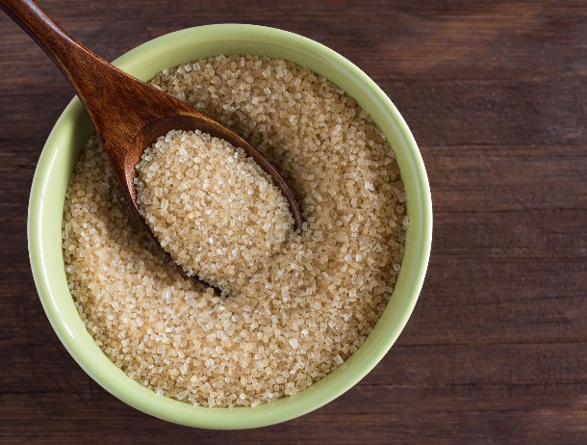
- Herbal teas can’t be used alone but can be used 50/50 with black tea – make sure it is straight herb with no oils.
- Water must be non-chlorinated (like spring water).
- Sugar should be sucrose-based such as organic sugar, sucanat, coconut sweetener, or palm sugar.
- Raw honey should not be used as it contains good bacteria which may interfere with the SCOBY’s bacteria.
- Flavouring kombucha occurs after the SCOBY has been removed.

Recipe
Container | Tea | Sugar | Water | Starter | SCOBY Size
1 litre or 1 quart | 1 tea bag | 1/4 cup | 2–3 cups | 1/2 cup | 56– 63 g or 2–2.5 ounces
2 litres or 1/2 gallon | 2 tea bags | 1/2 cup | 6-7 cups | 1 cup | 112–125 g or 4–5 ounces
4 litres or 1 gallon | 4 tea bags | 1 cup | 13-14 cups | 2 cups | 225–250 g or 8–10 ounces

Making the Kombucha
- A portion of water is boiled, and the tea is steeped in the water for 15 minutes.
- The tea bags are removed, and the sugar is added to dissolve it. The tea is transferred to a fermenting vessel, which is usually a large glass jar, and more water is added to fill the jar to about one inch below the rim.
- The SCOBY is added along with some starter.
- Recipe will vary depending on the size of the SCOBY.
- Starter is kombucha from a previous batch – do not use store-bought kombucha.
- Apple cider vinegar can be used if kombucha starter is not available.
- Place a tightly-woven mesh cloth (no cheesecloth) and secure with an elastic band.
- Place in a warm place (70–85 degrees F or 21–29 C) and let it ferment for 7–21 days.
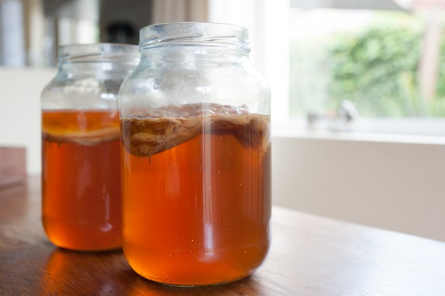
After the Fermentation Process
- Use pH paper to check the process and to know when it is done.
- Once the kombucha is ready, remove the SCOBY and 2 cups of liquid to use for the next batch.
- Strain the kombucha through a mesh strainer to remove any sediment.
- Transfer into clean jars with lids and either refrigerate or use for second fermentation.
Second Fermentation
- Now that the SCOBY has been removed, a second fermentation can be done to increase the numbers of beneficial organisms and increase the carbon dioxide (the fizzy).
- Ferment at room temperature for another 24–48 hours and then refrigerate.
- Flavours such as fruits, herbs, and essential oils can be used to create delicious and unique beverages.
- Remember, fruit ferments into alcohol so if using fruit – only do second fermentation for 12–24 hours.
- If not doing another batch, then place the SCOBY and the starter in a glass or plastic container with a lid and store in the refrigerator.
- It will keep for a couple of months.
Continuous Brewing
- This is a process where at least 20 percent of the kombucha is left in the fermenting vessel. Only what you want to consume is drained off.
- New tea, sugar and water is added (prepared as usual and allowed to cool) as well as the SCOBY and left to ferment again.
- This method provides the healthiest environment for the SCOBY and prevents any chance of developing mold.
- It is also low maintenance and allows for the most consistent product.
- Usually a large vessel is used – 1 to 5 gallons or 4 to 20 litres, and the vessel need to contain a spigot.
- This also encourages a large SCOBY and bigger new SCOBY’s so cut the SCOBY to keep the size consistent and to keep it well fed and healthy.
Making the best kombucha is a craft. Practicing the preparation of kombucha is going to allow you to learn to make it well. The key is to experiment with the timing for fermentation and the flavours. It does taste better than the store bought, and the flavours are often richer. Give it a try and enjoy!

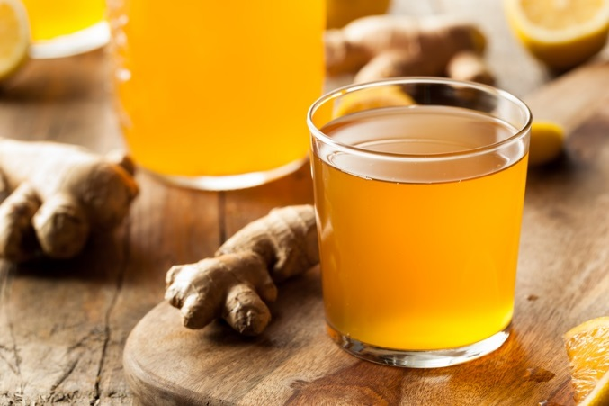
Tips for Adding Kombucha to Your Daily Diet
- The decision to start making kombucha on a regular basis requires a commitment.
- Perhaps start with buying kombucha and once you know you like it, get the SCOBY to make your own.
- Kombucha is a beverage and there is nothing wrong with just consuming it as that – especially if you flavour it to your liking.

How to Add It to Your Diet
- Kombucha makes a great smoothie base.
- Make ice cubes with it for a unique taste.
- Add some to your morning coffee.
- Add it in place of some of the vinegar and oil in a salad dressing, or just add it to your favourite dressing.
- Add it to hummus or other dips.
- Make kombucha mustard by fermenting the ground mustard seeds in a small amount of kombucha (second fermentation).
- Use it as a marinade for meats and vegetables (add other herbs, garlic, and onions as desired).
- Serve it over ice cream or make a shake with it.
- Whatever you choose to do, once you start making kombucha, make it consistently for best results and to keep your SCOBY healthy. Enjoy!
Tip
Do you like pop? Add your favorite juice 50/50 with kombucha. The juice ups the fruit flavour, and the kombucha makes it fizzy like pop.

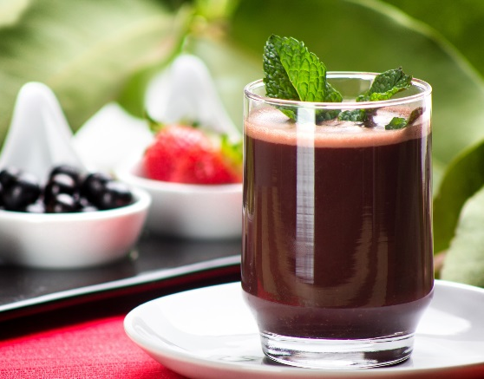
Kombucha Fruit Smoothie
- 1 1/2 cups kombucha
- 1 tbsp chia seeds, ground
- 1 apple, cored but not peeled, cut into pieces
- 1/2 cup frozen wild blueberries
- 1/4 cup frozen raspberries
- 2 tsp maple syrup
- 1/4 tsp ground cinnamon
Place all the ingredients in a blender and blend. Pour into a tall glass and serve.

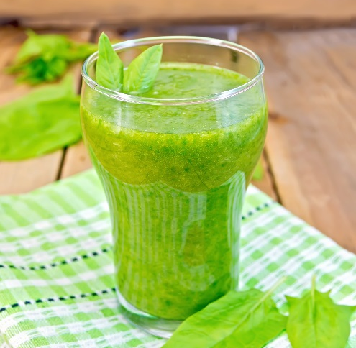
Kombucha Avocado Smoothie
- 1 cup kombucha
- 1/2 avocado, peeled and pitted
- 1 lime, juiced
- 1–2 cups baby spinach leaves
- 1 tbsp chia seeds, ground
- 1 tbsp white onion

Place all the ingredients in a blender and blend until smooth. Pour in a tall glass and serve.

