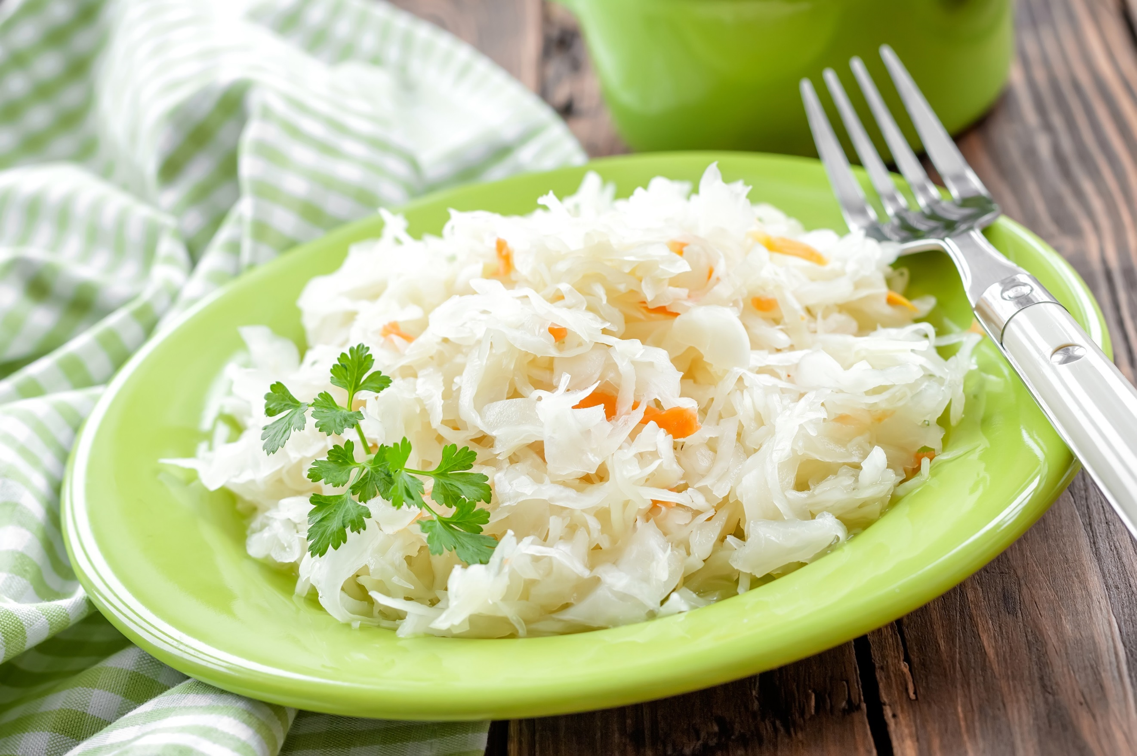
Insert Name Here
The Art of
Making Sauerkraut
Hello.
I am so pleased to offer you this information about making sauerkraut. Fermentation is a traditional preservation technique for creating foods with even more health properties because they have been fermented.
Beneficial bacteria are essential for a healthy gut, and a healthy gut is necessary for a healthy body. Fermented foods such as sauerkraut deliver beneficial bacteria to help the gut and help you. It’s a fascinating technique, and I’m sure you will enjoy learning to make your own sauerkraut.

Signature
 (Place HEADSHOT)
Contact info (optional)
(Place LOGO)

Medical Disclaimer
All information contained in this document is for informational purposes only. It is not intended to diagnose, treat, cure, or prevent health problems. For all serious health issues, please contact a medical or nutrition practitioner. The information provided in this program is based on the best knowledge of the author at the time of writing, and we do not assume liability for the information within this program, be it direct or indirect, consequential, special, exemplary, or other damages. In all circumstances, it is always wise to consult your physician before changing your diet, taking supplements, or starting any exercise or health program.
Sauerkraut means “sour cabbage” and it has a long history. The earliest record was 2000 BC in China – it was made with rice wine. It’s presumed that it was brought to Europe by Genghis Khan. Roman writer Cato mentions preserving cabbage and turnip with salt. The French call it “choucroute.” Ships to North America often carried sauerkraut to prevent scurvy and disease. Eastern European families would make several barrels to last them throughout the winter.
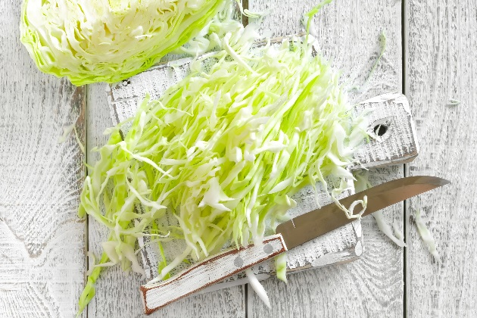
Sauerkraut is made by “sweating” the juice out of the cabbage with salt to create a brine. This is a simple process of rubbing cabbage with the salt. All the benefits of cabbage are present but in a more bioavailable form. Other vegetables or herbs can be added to increase the nutrient diversity and to add to the flavour.
Sauerkraut has many benefits. It is antimicrobial and antifungal, and the juice can be used to preserve other foods. Phytonutrients found in cabbage, known as isothiocyanates, may have anticancer benefits and may be helpful with ulcers. Sauerkraut aids digestions and helps digestion of other foods in the meal. It also contains prebiotics which help feed our own good bacteria.

The Process of Making Sauerkraut
- Sauerkraut is shredded cabbage rubbed with salt.
- Liquid is drawn out of the cabbage to create a brine.
- Cabbage and brine are put in an airtight glass jar and weighed down to prevent the cabbage from being exposed to the air.
- Lacto-fermentation takes place inside the jar.

Lacto-fermentation
- Lacto-fermentation for sauerkraut is an anaerobic process which means it takes place without oxygen.
- If cabbage pokes above the liquid, it can mold, especially if air is allowed in the jar.
- Leuconostoc mesenteroides is the first organism, and it produces carbon dioxide which pushes out the oxygen in the jar. Various lactobacillus strains will then develop in the jar in the next 3–10 days.
Tips

- At the beginning the pH is seven, and it should be four after it is finished.
- It will take 10 days minimum.
- Two weeks is best for the ideal amount of strains.
- If the brine level is too low, then it will spoil.
- If there is too little salt, then the bad bacteria may not be held at bay while the good bacteria are developing.
- Ideal temperature is 70–85 degrees F (21–30 degrees C). The warmer the temperature, the faster it will ferment.
- If oxygen is present, then cabbage will darken (and vitamin C is being lost).
- If it is pinkish, then yeast is present which is also not good.
- If mold forms, throw it out – do not just scrape it off.

Equipment Needed:
- Glass jar with a lid
- Wooden spoon or kraut pounder
- Sea salt or Himalayan salt
- Cabbage
- Knife or shredder

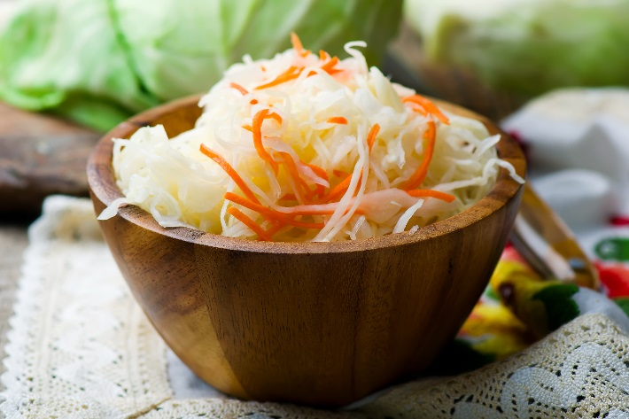
Making Sauerkraut
This is a small batch and a bigger batch can be made once you are comfortable with the process. Remember that making sauerkraut is an anaerobic process, which means the air is not needed. Oxygen is the enemy so it’s key to keep the cabbage submerged in liquid. The jar should have a lid that can be screwed on tightly.

Recipe:
- 1 litre- or 1 quart-Mason jar with lid
- 1/2 head of cabbage (1–1 1/2 lbs or 450–600 g)
- 2–3 tsp sea salt
Make sure the jar and lid are thoroughly clean and dry. Pull off the outer leaves of the cabbage. Cut in half and cut out the core. Chop or shred the cabbage into small pieces.* Place all the cabbage into a bowl and add sea salt. Cover with a plate and let sit for half an hour. Start rubbing the cabbage to draw out the liquid so that the cabbage starts to wilt.
Once some liquid is visible, start adding the cabbage to the jar. Use a utensil like a wooden spoon (do not use a metal spoon) to press and pack the cabbage down in the jar. Continue this until the cabbage is all in the jar. Leave enough space for the weight. Add a weight to keep the cabbage pressed down and submerged below the liquid. An easy way to do this is to put a smaller jar inside the bigger jar and put some stones or marbles in the smaller jar. Place a lid on top and screw it on tightly.
Ferment for 7–14 days. You may ferment it up to four weeks, but it’s not really necessary. It’s a matter of personal taste preference. Once it has reached the taste and texture you like, open it up and remove the weight. Put the lid back on and put it in the refrigerator. Use as desired.
*The smaller the pieces, the easier it is for the salt to draw out the water. Chopping into small pieces is one option. Another option is to shred the cabbage on a cheese grater using the side with the biggest holes. Putting the cabbage through a shredding blade in a food processor is also an option and is best for large amounts of cabbage.
Save the sauerkraut juice. This can be added to the next batch, creating more liquid to make it easier to prepare.
Tip

Alternative Recipe - Wine Sauerkraut:
The original sauerkraut was made with wine.
- 1/2 head of cabbage (1 – 1 1/2 lbs or 450–600 g)
- 1 1/2 tsp sea salt
- 2 tbsp white wine such as Chardonnay or Riesling or rice wine*
*Another great option is to use red wine such as Merlot or Pinot Noir and red cabbage.
Follow the procedure above. Add the wine once you have obtained enough juice from the cabbage. Less juice from the cabbage is needed since the wine will add more liquid. This will also ferment faster.

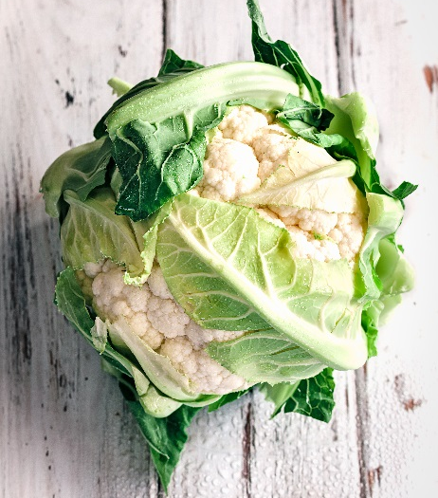
Adding Other Foods to Sauerkraut
Now that you know how to make sauerkraut, experiment. Before fermenting, add other ingredients to the cabbage. This will provide you with even more nutritional benefits. Feel free to add more than one ingredient. Make it to your own taste. Here are a few suggestions:
- Kale
- Carrots or parsnips
- Chia seeds
- Beets
- Onion or garlic
- Ginger
- Broccoli or cauliflower

Tips for Adding Sauerkraut to Your Daily Diet
Now that you know why and how to make sauerkraut, let’s talk about how to add it to your daily diet. Remember to consume it in a reasonable time frame after making.

How Much Do You Need Daily?
1/4 cup of sauerkraut is enough. 1/2 cup is also a reasonable amount. Go slow and make sure you know how you react to it.

Do You Need It Daily?
No, unless you find it specifically helpful to you. Sauerkraut can be part of a wider choice of fermented foods and consumed 2–3 times a week.
Tips

Here are some easy ideas for you to try:
- Add it to your favourite hummus – chop it first.
- Puree the sauerkraut with the juice and use it to replace the vinegar (and the salt) in a salad dressing Add it to any smoothie.
- Mix it in with cooked veggie dishes .
- Mix 1/2 cup of chopped sauerkraut with 1 cup of apple applesauce to serve with an entree.
- Use it as a condiment on a sandwich or hamburger.
- Mix it with cream cheese, yogurt, yogurt cheese, or kefir cheese. Add chopped green onion, your favourite herbs, and black pepper for a great dip or spread.
- Top a sushi roll with sauerkraut.
- Add it on top of soups. Serve it mixed in with scrambled eggs.
- Add it to potato salad or bean salad.
- Mix it into mashed potatoes, or add it to a baked potato or sweet potato.
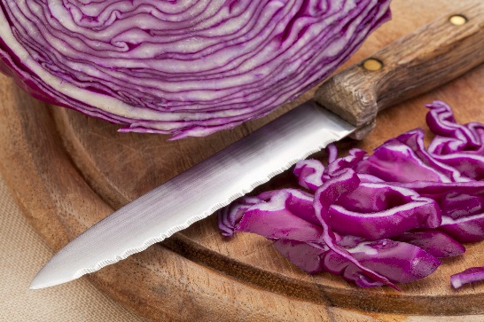
- Eat as a digestive starter just before a meal.

Cooking with Sauerkraut
There are still some health benefits when you cook with sauerkraut. Most recipes on the internet involve cooking with sauerkraut. Once the cabbage is fermented, the nutrients are more bioavailable. Bacteria has produced metabolites that help the immune system, and the cabbage is partially digested. All of this is still present when the sauerkraut is cooked. The good bacteria and enzymes, however, are lost, but it still has nutritional value.
- A Chocolate Sauerkraut Cake is a tasty treat.
- Add sauerkraut to the filling of cabbage rolls.
- Puree in the food processor and add to a meatball mix or a veggie burger mix.
- Make a savoury pancake with some herbs and sauerkraut and serve with maple syrup.
- Think outside the box and find the ways that work for you.

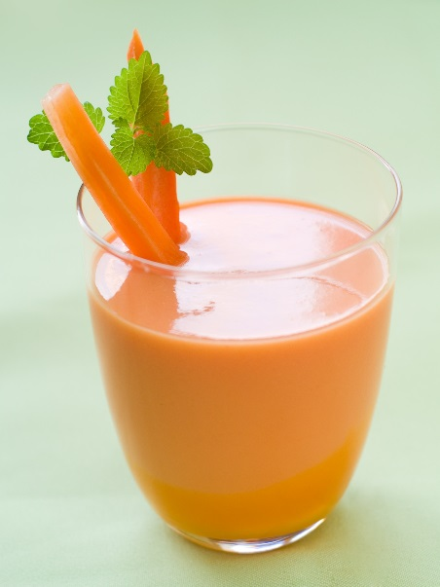
Orange Sauerkraut Smoothie
- 2 tsp chia seeds, ground
- 1/2 cup spring water or kefir water*
- 1/2 cup sauerkraut
- 1 carrot, cut into pieces
- 4 fresh or dried dates, pitted
- 1 orange, peeled, seeds removed
Place all the ingredients in a blender and blend until smooth. Pour into a glass. Chill if you prefer a colder smoothie.
*If your blender can handle ice cubes and you would like a cold smoothie that can be used right away, reduce the water and add some ice cubes.

Tomato Sauerkraut Soup
- 1/2 tbsp butter

- 1/2 cup chopped onion
- 1 clove garlic, peeled and chopped
- 1 14 oz (398 ml) can diced tomatoes, salt free
- 2 cups bone, chicken or vegetable broth or 1 cup broth mixed with 1 cup spring water
- 1–2 tsp dried savory or thyme
- 2 celery stalks, sliced
- 1 Jerusalem artichoke, peeled and sliced
- 2 cups spinach
- Sea salt and black pepper to taste
- 1/2 cup sauerkraut
Melt the butter with onions in a medium saucepan and lightly sauté the onions. Add the garlic and stir. Pour in the tomatoes (with juice) and add the broth and the savory or thyme. Bring to a boil and low to simmer. Add the celery and Jerusalem artichokes. Continue to simmer until the celery and Jerusalem artichokes are soft. Add the spinach and cook for one minute. Remove from the stove and season to taste with sea salt and pepper. Spilt the soup between two bowls and top each bowl with 1/4 cup of sauerkraut. Serve. If there is any left over, put it in an airtight container and freeze or refrigerate it to eat another time.
Add a tablespoon of yogurt or kefir to add another fermented food to this recipe.
Tips

German Chocolate Sauerkraut Cake
This is a traditional recipe with a modern twist. Don’t knock it until you try it – as weird as it might seem. It is moist and light. This recipe dates back to the 1950’s so to update it, I have suggested adding either some cinnamon or chili powder as an option as both work well with chocolate. These are not necessary as it is delicious all on its own.

- 1/4 cup plus 2 tsp butter
- 3/4 cup organic sugar
- 2 eggs
- 1/2 tsp pure vanilla extract
- 1 cup unbleached all-purpose flour or 1/2 cup all-purpose mixed with 1/2 cup whole spelt
- 11/2 tsp baking powder
- /2 tsp baking soda
- 1/4 tsp sea salt
- 1/4 cup cocoa
- 1/2 tsp ground cinnamon or chili powder (optional)
- 1 cup (4 oz or 112 ml) sauerkraut, drained and rinsed with water
- 1/2 cup spring water


Preheat the oven to 325 degrees F. Grease and flour an 8 x 8-inch pan or grease the sides and line the bottom with parchment paper. Put the butter and sugar in a mixer bowl and beat until the butter is soft. Add the eggs and the vanilla. In another bowl, mix the flour, baking powder, baking soda, sea salt, cocoa, and cinnamon or chili powder (if using) together. Meanwhile, rinse the sauerkraut with water and drain. Place the sauerkraut in a food processor or blender and puree. You may use half the water to help the sauerkraut puree. Add the flour-cocoa mixture to the butter mixture and gradually add the rest of the water. Add the sauerkraut and mix. Be sure to scrape the side of the bowl so it is mixed completely. Add the batter to the cake pan. Bake at 325 degrees F for 30-35 minutes. The cake is ready to come out of the oven when you touch it lightly with your fingers and it springs back. Remove from the oven. Let it sit for five minutes. Go around the edge with a palette knife to loosen the cake from the pan. Turn upside down on a wire rack. Let cool. Cut into pieces and place each piece on a plate. Drizzle with Chocolate Glaze.

Chocolate Glaze

- 1 cup semi-sweet chocolate chips*
- 1/2 cup whipping cream or full-fat coconut milk
- 1 tbsp butter or coconut oil

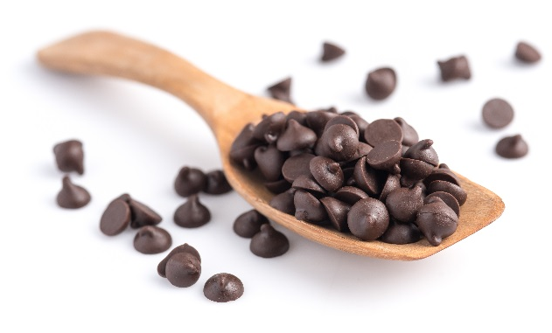
Place the chocolate in a bowl. Put the cream or coconut milk and butter or coconut oil in a small saucepan. Bring to a boil. Pour into the bowl with the chocolate and let it melt the chocolate. You may not want to add all the cream or coconut milk at once since you want to make sure the consistency is how you like it. You can always add more after. Make sure there is enough to cover the chocolate and melt it. Whisk until smooth. Let cool a bit before drizzling over the cake.
*Another option is to use a 70% cocoa solid chocolate bar and chop it into pieces to make one cup. This will give the glaze a stronger dark chocolate taste.

