
Workshop Handbook
Table of Contents
The Benefits of Fermented Foods 2
Fermentation Rules 2
Using Starters: 3
Fermenting with Sea Salt: 4
Making a Brine: 4
Making Sauerkraut 5
Beet Kvass 6
Kimchi 6
Cream of Cauliflower Kimchi Soup 7
Berry Sorbet 7
Yogurt Cheese Salsa Dip 7
Kefir Sourdough Bread 8
Kefir Sourdough Crostini or Toasts 8
Cultured Vegetables 8
Fermented Salsa 9
Amaranth Crackers 9

The Benefits of Fermented Foods
Many years ago, our ancestors developed a process to preserve foods. By allowing food to sit and developed billion of bacteria strains and sometimes yeast strains, they turned ordinary foods into superfoods. Fermentation is a simple but controlled process that modern research has confirmed works to preserves the food and potentiate the nutrients. Multiple studies have also confirmed that fermented foods have many health benefits.
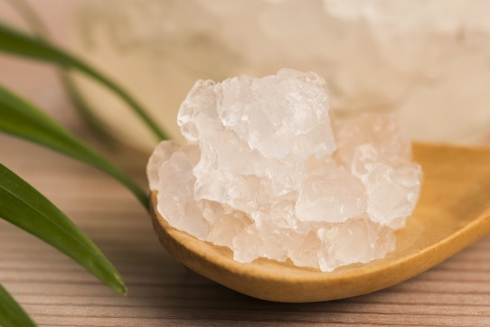
Benefits of Fermented Foods:
- Antimicrobial: The good bacteria inhibits the bad plus there may be unique chemical in a fermented food that also inhibits pathogens.
- Aids Digestion: Consuming a serving of fermented food with a meal aids digestion of the entire meal
- Contain Beneficial Bacteria and Yeast Strains: Even though they are only there temporarily, these strains help our own bacteria do their job
- Makes Nutrients More Bioavailable: All nutrients in the food that is fermented will be easier for the body to access and use.
- Immune Supportive: Bacteria and yeast strains in fermented foods helps improve immune function
- Anti-Inflammatory: As part of the support of the immune system fermented foods can help regulate inflammation in the body
- Contain Prebiotics: This helps to feed the beneficial bacteria in the body
- Aid elimination of Waste Material: Ensures toxins and wastes leave the body
- Supports the Brain-Gut Connection: Just one of the many relation ships the gut has with other parts of the body
- Supports Overall Gut Health: All health issues have been connected to the gut
The process of making fermented foods is quite simple. By either use a starter or scoby or a salt salt brine, bad bacteria is inhibited to give the good bacteria to have the upper hand. Once this occurs, bad bacteria and mold cannot grow.

Fermentation Rules
- Only use water that has no chlorine such as spring water or filtered water – do not use reverse osmosis or distilled. Reverse Osmosis that has been re-mineralized can be used but natural water is best.
- Use glass or plastic for containers – glass or ceramic is best but plastic can be used. Do not use metal of any kind including stainless steel

- Utensils should be plastic or wooden – no wire whisks or metal spoons
- Always make sure any containers used are clean and soap-free
- For straining our vegetables, kefir grains or kombucha scoby, use a nylon mesh strainer – again, no metal.
- No matter what technique used – vegetables and fruits must be submerged in liquid. The liquid may be from the vegetable itself, starter and water or a brine.
- Ideal room temperature for most items that are being fermented is 70 -75 degrees F (20 -24 degrees C). If the temperature is too warm it will ferment too fast and could possibly spoil. If is too cold – it could take too long and possible spoil as well. Sourdough starters and sourdough bread can ferment at a higher temperature 85-95 degrees F (29-35 degrees F).
- Fruits and salsas are not as sea salt friendly (from a taste perspective) so using another type of starter may be best and some sea salt can be added if desired but not as much as vegetables. Starters, including vegetable starters can be used for fruit which should ferment for about 2-3 days. Consume it within 4 week as it will become alcohol.

Using Starters:
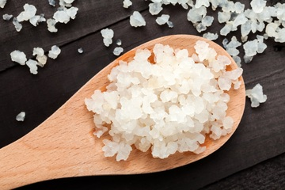
- A starter is anything that contains good bacteria that can speed up the fermentation process. You can buy starters or make your own.
- To make your own starter: Straining yogurt or kefir through a cloth creates a cream cheese from the yogurt and the whey drains through. This can be used as a starter. You can do this with cow’s yogurt or kefir, coconut, sheep or goat yogurt: Here is a video link to show you how http://www.youtube.com/watch?v=lw0gRpIB-Cg Liberte kefir may be to liquidity to be strained to collect the whey.
- Water kefir can also be used as a starter for other types of fermented foods.
- Juice from sauerkraut can also be used but this is best for making more sauerkraut and it is best that the juice comes from sauerkraut you make yourself
- Wine –red or white, can be used as a starter – 1-2 tbsp per 2 cups liquid is enough – it depends if you are still using some sea salt.
- Any juice from any vegetable ferment can be used to speed up the fermenting of new vegetables
- Generally 1-2 tablespoons added to the vegetables or fruit plus water if needed for at least a 500 ml container and up to ¼ cup for a litre container.
- Most recipes using any of these starters including a vegetable starter also require some sea salt

Fermenting with Sea Salt:
- Using sea salt to ferment slows the fermentation process so there is less chance for undesirable organisms to grow and makes it easier for good bacteria to ferment the ingredients.

- There are two ways: Rubbing the sea salt into the vegetables to draw the juice our before putting the vegetables – this works well with cabbage, carrots and other roots vegetables. Usually, no added water is needed (although you can add it if necessary). Weights will be needed to keep the fermenting vegetables submerged. The second way is to make a brine.

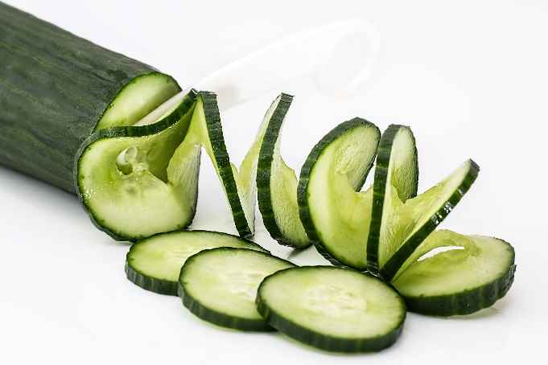
Making a Brine:
Mixing water and sea salt together to make a brine is another way to ferment using sea salt. It is good for soft vegetables like zucchini and cucumber as well as vegetables like cauliflower and broccoli that would be damaged by the rubbing process with sea salt. 2-3 tsp sea salt for 1 cup water is the general rule. This is poured over the vegetables in the fermentation container like a mason jar. This is also a good techniques for kimchi, beet kvass and large pieces of vegetables.

Making Sauerkraut
This is a small batch and a bigger batch can be made once you are comfortable with the process. Remember the making sauerkraut is an anaerobic process, which means the air is not needed and oxygen is the enemy so it key is to keep the cabbage submerged in liquid and the jar should have a lid that can be screwed on tightly.
- 1 litre or 1 quart Mason jar with lid
- 1/2 head of cabbage (1 – 1½ lbs or 450-600 g)
- 2-3 tsp sea salt
Make sure the jar and lid are thoroughly clean and dry. Pull off the outer leaves of the cabbage. Cut in half and cut out the core. Chop or shred the cabbage into small pieces. Place all the cabbage into a bowl and add sea salt. Cover with a plate and let sit for ½ an hour. Start rubbing the cabbage to draw out the liquid and the cabbage starts to wilt. Once some liquid is visible, start adding the cabbage to the jar. Use a utensil like a wooden spoon (do not use a metal spoon) to press and pack the cabbage down in the jar. Continue this until the cabbage is all in the jar. Leave enough space for the weight. Add a weight to keep the cabbage pressed down and submerged below the liquid. An easy way to do this is to put a smaller jar* inside the bigger jar and put some stones or marbles in the smaller jar. Place a lid on top and screw it on tightly. Ferment for 7-14 days. You may ferment it up to 4 weeks but it is no really necessary and it is a matter of personal taste preference. Once it has reached the taste and texture you like. Open it up and remove the weight. Put the lid back on and put it in the refrigerator. Use as desired.
*The smaller the pieces, the easier it is for the salt to draw out the water. Chopping into small pieces is on option. Another option is to shred the cabbage on a cheese grater using the side with the biggest holes. Putting the cabbage through a shredding blade in a food processor is also an option and best for large amounts of cabbage.
Note: Add caraway seed or celery seeds for extra flavour
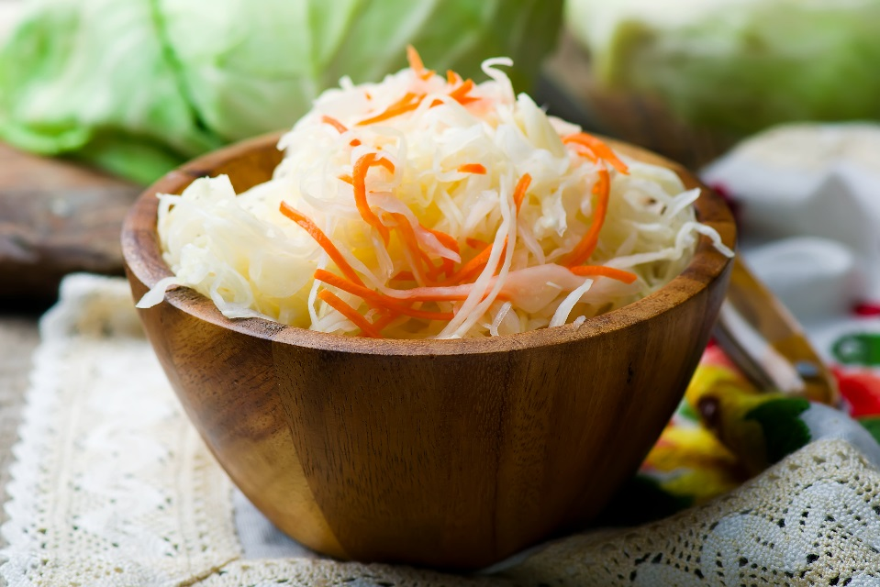

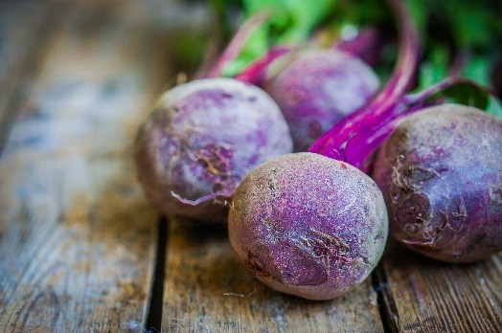
Beet Kvass
- 1/2 litre glass Mason jar
- 1 medium beets, cut into small cubes – do not peel (should fill 1/3-1/2 the jar)
- 3/4 teaspoons sea salt
- Spring water to fill the jar
Place the beets in the Mason jar. Add the sea salt. Fill the jar with water leaving about one inch of space at the top of the jar. Place the lid on top and let ferment for 7 days. This process can be sped up by adding 1-2 tbsp whey or 1-2 tsp vegetable starter and the kvass can be ready in 3 days.
If you do not like beets, you will not like beet kvass but it has great health benefits. To improve the flavour, do a mixture of cabbage and beets and add onions. Celery can be used instead of cabbage. Also try it with yellow beets.


Kimchi
- 1/3 head of Chinese cabbage, chopped
- 1/3 medium daikon radish, thinly sliced
- 1 carrots, peeled and sliced*
- 1 ½ tablespoon white onion, chopped or 4 green onions, chopped
- 2 small cloves garlic
- 1 tbsp grated fresh ginger
- 1-2 tsp hot red pepper powder
- Brine – made from 1-2 cups spring or filtered water and 2-3 tsp sea salt
- 1/2-litre Mason jars with lids
Dried Bonito flakes or dried shrimp (optional)**
Place the cabbage, daikon radish, carrots and onions in a bowl and mix.
Divide the vegetables between the two jars and use a wooden spoon to pack the vegetables in the jar. Split the ginger, garlic and red pepper powder and fish (if using) between the two jars and gently mix through the vegetables. Pack down again. Pour the brine mixture in each jar and make sure the water covers all the vegetables. If you need more liquid then make more brine. It is one cup of water to one tablespoon sea salt. Put the lid on each jar and let ferment for 4 days to 1 week.
*Peeling the carrots is a personal choice. In fermentation circles, it is considered better to not peel the carrots as the skin often contains trace amounts of beneficial bacteria from the soil.
**Different types of dried fish are often added to kimchi. Make sure it is just a dried fish with nothing added. For example some recipes call for Hondashi fish powder which contains MSG and it should not be used. Adding dried fish is optional. Dried anchovies would be good as this would add beneficial Omega 3 to the kimchi.

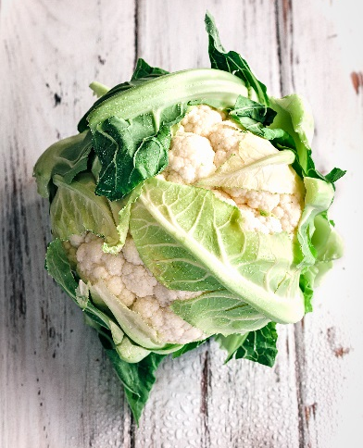
Cream of Cauliflower Kimchi Soup
Serves 2-3 people
- 1 tbsp butter or coconut oil
- 1/2 cup chopped onions
- 2 cups chicken or vegetable broth (or 1 cup broth and 1 cup water)
- 1 clove garlic, chopped
- 4 cups chopped cauliflower
- Sea salt and pepper to taste
- 1/2 cup full-fat coconut milk
- ½ cup parsely
- 1/4 to 1/2 kimchi per person
Saute the onions in the butter lightly. Add the garlic and cauliflower and saute for about 2 minutes. Be sure to stir it. Add the broth and bring to a boil. Lower to simmer. Cover with a lid and cook until cauliflower is soft (about 10-20 minutes). Add the coconut milk. Puree the soup with a hand blender or transfer to a blender and puree until smooth. Season with sea salt and pepper to taste. Add the parsley. Pour the coup into bowls and tip with kimchi

Berry Sorbet
- 2-3 cups frozen berries
- 1/3 cup water kefir or 2 tbsp white wine mixed with 1/4 cup spring water
- 2 tbsp honey, coconut sweetener or sucanat
Puree the fruit and either water kefir or wine mixed with water together. Place in a jar with and lid and let ferment for 12-18 hours. Add the sweetener of choice to taste. Place in an ice cream machine and churn. Once it is churned transfer the mixture to the plastic container with a lid and put in the freezer. Let it freeze for at least 2-4 hours before serving.
As an alternative, 1/2 cup full-fat kefir or full-fat yogurt could be added after it ferments for a creamier sorbet.

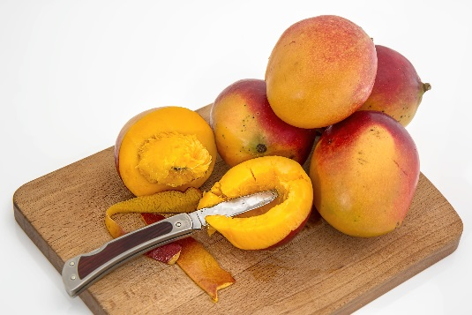
Yogurt Cheese Salsa Dip
- 1 ripe mango, peeled, pitted, and diced (about 1 1/2 cup)
- 1/2 medium red onion, chopped
- 1 clove garlic, chopped
- 1 Jalapeño pepper, chopped (optional)
- 1 small cucumber, peeled and diced (about 1 cup)
- 1 celery stalk, sliced
- 3 tbsp fresh cilantro leaves, chopped
- 3 tbsp fresh lime juice
- Sea salt and pepper to taste
Combine all of the ingredients in a bowl. Season to taste with sea salt and pepper. Mix with 1 cup yogurt cheese or coconut kefir. Serve with whole grain chips or crackers.

Kefir Sourdough Bread
The easiest sourdough ever!

- 1 cup Liberte kefir or homemade kefir made with kefir grains
- 1 cup organic white wheat flour
- 1 ½ cups whole wheat flour
- 1 tbsp organic sugar or maple syrup (or half organic sugar and half sucanat
- 2-3 tsp olive oil
- ½ tsp sea salt (added later)

Mix the kefir, flours, sugar, and olive oil together in a bowl. More kefir may be needed to make a smooth dough. Transfer to a clean surface and knead for 5-10 minutes. Use extra flour for dusting as needed. Grease a bowl with olive oil and place the dough in the bowl. Cover with plastic wrap and pace in a warm spot. If you have a proofer set the temperature between 85-95 degrees F (18-24 degrees C) and put the bowl in the proofer. Otherwise, find a warm spot such as on top of the refrigerator. Let the dough ferment for 24 hours. It should double in size. Punch the dough down, sprinkle with sea salt and work the salt into the dough. If the dough is too sticky, add more flour. Transfer to a clean surface and knead the dough a bit to make sure the salt is mixed thoroughly.
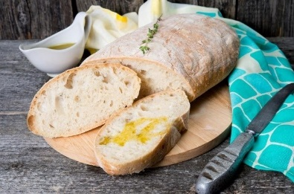
If making a loaf of bread: Shape the dough into loaf and place in a loaf pan that has been brushed with olive oil. Let double in size. Bake at 350 degrees F for 25 minutes.
If making ciabatta or a baguette. Shape the loaves and place them on a baking tray that has been brushed with olive oil or line it with parchment paper. Let double in size. Bake at 350 degrees F for 25 minutes.

Kefir Sourdough Crostini or Toasts
Slice the Kefir Sourdough Bread thinly. Lightly brush the olive oil (or butter), sprinkle with sea salt and your favourite herb. Bake at 275 degrees F for 13 minutes. Remove from oven and turn each piece of bread upside down. Bake for another 13 minutes. Remove from the oven and let cool. The bread should now be crunchy.

Cultured Vegetables
- 1-2 cups cauliflower, carrots, zucchini or broccoli (cut into small pieces)

- 1 1/2 tablespoons curry powder
- 3 cloves of garlic, chopped
- 1 tbsp sea salt
- 2 cups water

- Seasoning to taste (optional) (oregano curry, cayenne, garlic, onions)
Make the brine by mixing the sea salt and water together. Prepare the vegetables. Place them in a jar. Add any seasoning you are choosing. Leave about on inch of space from the top of the jar. Pour on the brine and cover the vegetables. Cover with a lid and let ferment for 3 to 7 days until fermented. Turn upside down every day until there is gas build up to keep the vegetables covered in the brine. Once the vegetables are fermented, store in the refrigerator.

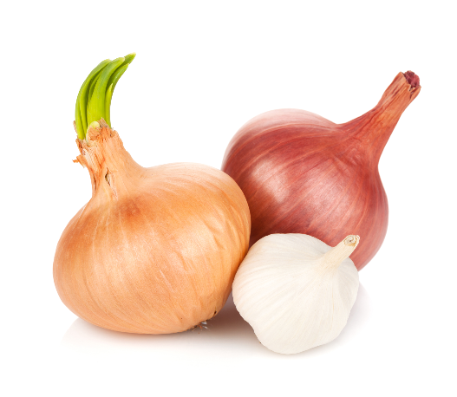
Fermented Salsa
- 1/2 medium onion, chopped
- 1 pint cherry tomatoes, chopped
- 1/2 medium red pepper, chopped
- 1/2 a jalapeno pepper (more for a hotter salsa)
- 1 clove garlic, chopped
- 2-3 tbsp fresh cilantro, chopped
- Rind and Juice of one lime to taste
- One of the following:
- 2 teaspoons sea salt
- Or 1 to 2 teaspoons sea salt and 1/4 cup whey
- Or 1 to 2 teaspoons sea salt and 1/4 cup water kefir
- Or a starter culture such as Caldwell’s Cultured Vegetable Starter and sea salt as indicated by the instructions for the specific culture you are working with
If using a starter culture, prepare the culture according the package instructions. Mix all the ingredients except the lime juice together including the salt, whey, or starter culture. Place the salsa in a mason jar; use a wooden spoon to press it down to release some of the juice. The vegetables should be submerged under the liquid. Extra water can be added if needed. Cover with cheese cloth if not using whey or water kefir. If using, whey or water kefir it can be covered with a lid, but open it up after two days to let the gas out. Re-seal and continue to ferment if you want*. Ferment for at least 3-4 days at room temperature. Once you are satisfied with how much it has fermented, ass lime juice to taste. Store it in a the refrigerator.

Amaranth Crackers
- 1/2 cup amaranth flour or 3/4 cup cooked amaranth*
- 1 tbsp water (if using amaranth flour)
- 1/2 cup sunflower seeds
- 1 tbsp white onion, chopped
- 1/2 tsp thyme, fresh
- 1 tbsp coconut oil
- Sea salt and pepper to taste
- 1 strip bacon (optional)
Heat the oven to 300 degrees F. Place on the ingredients in a food processor and process until is smooth. Prepare a baking sheet by greasing with coconut oil or lining with a sheet of parchment paper.
Amaranth Flour: Chill the dough for 30 minutes to 1 hour. Roll out dough onto a lightly floured surface into a square or rectangle about 1/4 inch thick. Draw lines through it – 4 across and 4 down to form 16 squares. Transfer to the baking sheet. Place in the oven and bake for 10-15 minutes or until crisp. The thinner the cracker the faster it will bake.
Cooked Amaranth: Spread the mixture on the baking and spread it as thing as possible. Spread it in such a way that is forms a square or rectangle. Draw lines through the mixture – 4 across and 4 down to form 16 squares. Place in the oven and bake for 1-2 hours or until crisp. The thinner the cracker the faster it will bake.

